**Use Case Diagram**  
  
 Øvelse 1 : Kravs-indsamling for The Little Inn   
  
The software is expected to take care of   
• working hours for staff  
• commodity storage   
• room reservations  
• meal orders  
• recipes  
 Mr. Brown and his staff want more customers  
• to stay there for longer and/or   
• to eat at the Inn more often   
  
  
  
Øvelse 2 : Use cases (brief) for The Little Inn 1 fully dressed

UC1: Update working schedule  
Mr. Brown logs into the scheduling system with the schedules planned for everyone, enters them individually for each person and sees both a summary of each person’s schedule and a summary of the schedules of the entire staff, for a period of time manually specified. Mr. Brown then presses “save” and the system updates its stored schedule.

UC2: Storage / Inventory

Mr. Brown with the Inventory subsystem can check each day what the storage needs in regards to goods such as food, and therefore make sure that the storage is properly filled with food and goods. He can then make sure that the Inn does not run out of food and can therefore keep on serving the incoming customers on each day.

UC3: Reservations

A guest is able to use the Reservation subsystem that was put in place by the Software to make an reservation at the Inn, with the option of which table and time that are available for reservation.

UC4: Ordering a meal  
A guest or an employee logs into the meal subsystem to add one or more meals for a guest. They are presented with a list of dishes, are able to click on each to get additional info: a photo a list of ingredients and allergens. The person makes one or more choices and optionally adds a comment for any of the dishes with special requests, and clicks “Order” in order to save it.

UC5: Add recipe  
Anyone responsible for cooking logs into the recipe subsystem, with a recipe at hand to be entered. The person enters each ingredient, the quantity and the measurement, writes a description of the process and optionally attaches a photo. The recipe is shown in its entirety, with an option to save or discard, and the person saves it. The database is updated with the new recipe for future logins.

Øvelse 3 : Use Case diagram for The Little Inn

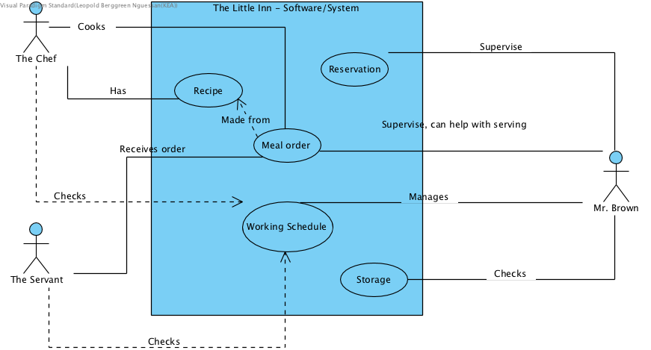

Øvelse 4 : Domain Model for accommodations

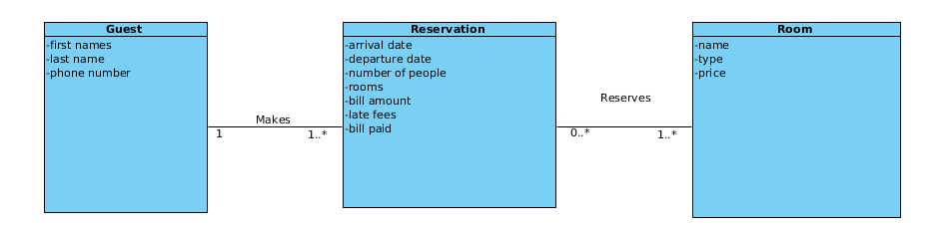

Øvelse 5: Domain model for the Inn

